**VISVESVARAYA TECHNOLOGICAL UNIVERSITY BELAGAVI-590018, KARNATAKA**



**A MINI PROJECT REPORT**

ON

**“COURIER MANAGEMENT SYSTEM”**

Submitted in partial fulfillment of requirements for the award of 5th semester,

**BACHELOR OF ENGINEERING**

**IN**

**COMPUTER SCIENCE & ENGINEERING**

Submitted By:

**CHIRAG D**

**(USN: 1MJ19CS716)**

Under the Guidance of

**Mrs. Tessy Rose R**

**Assistant Professor,**

**Department of Computer Science & Engineering**

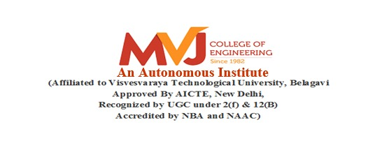

**DEPARTMENT OF COMPUTER SCIENCE & ENGINEERING**

**2021-2022**